**Implementing a Logistic Regression Model from Scratch with PyTorch for Truck Art (Birds)**

**PyTorch:**

PyTorch is a python package that provides two high-level features:

* Tensor computation (like numpy) with strong GPU acceleration
* Deep Neural Networks built on a tape-based autograd system

**Logistic Regression:**

Logistic regression, the outcome (dependent variable) has only a limited number of possible values. It is used when the response variable is categorical in nature. For instance, yes/no, true/false, etc.

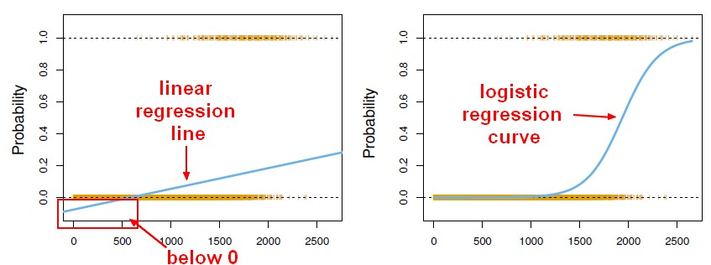

**Truck Art:**

Truck art in Pakistan popular form of regional decoration, featuring trucks decorated with intricate floral motifs and calligraphy.

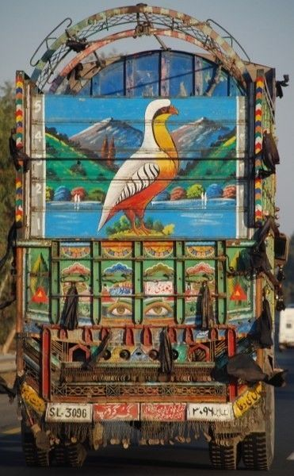Karachi is a major hub for truck art, although there are other hubs in Rawalpindi, Swat, Peshawar, Quetta and Lahore. Trucks from Balochistan and Peshawar are often heavily decorated with wood, while trucks from Rawalpindi and Islamabad often have plastic work. Camel bone detailing and the predominance of red colors are often seen on decorated trucks in Sindh.

**Logistic Regression Implementation:**

